Modeling Curved Windows

A) Introduction

Traditional window areas are simple to calculate. Find the length and width and start multiplying! More challenge is found when architects get creative and build whole building faces with flowing curved windows. Such a building is found near Branksome Hall Asia and I have used part of this building for my exploration.

Rationale

For curved windows, upper and lower window boundaries can be modeled with functions. The area between the curves can then be found using definite integration.

Alternatively, window areas can be found using trapezoids by breaking the windows up into discrete polygons.

Aim

My aim is to use both methods described above to approximate the total window area for a defined region on the building.

B) Developing the Models

The first step was to photograph the window.

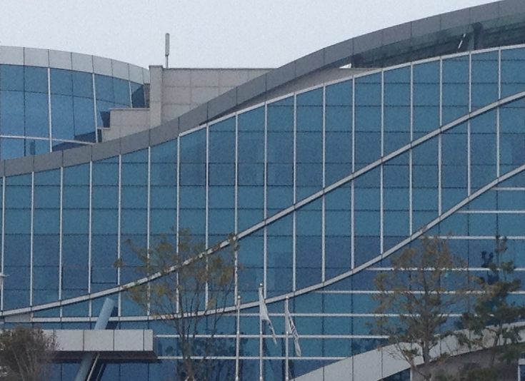

Figure 1. Photograph of Window Whose Area is to be Partially Modeled

The next step was to import it into a graphing program (Geogebra). I decided to add discrete points onto the graph which will be the target points for modeling the upper and lower curves, within the red bounded region.

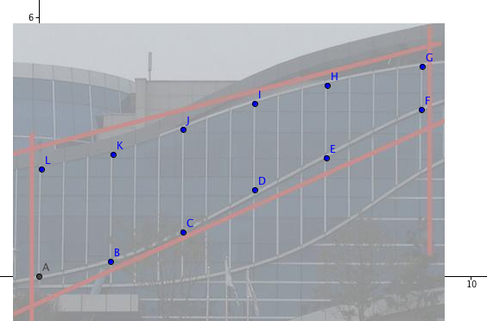

Figure 2. 12 Points (A-L) Representing Upper and Lower Curves of Window

Using the default grid on Geogebra, the 12 points are as follows:

Table 1. Values for the 12 points for modeling the upper and lower window curves.

 | A | B | C | D | E | F | G | H | I | J | K | L
x | 0 | 1.66 | 3.34 | 5.00 | 6.66 | 8.86 | 8.88 | 6.68 | 5.00 | 3.34 | 1.72 | 0.06
y | 0 | 0.34 | 1.02 | 2.00 | 2.74 | 4.86 | 4.86 | 4.43 | 4.00 | 3.40 | 2.82 | 2.48

The first method will use functions and integration. Due to the nature of the points layout, I will model the window boundaries with polynomial functions. Perhaps a 3rd degree will handle the double curve. Both curves appear to be increasing. I used adjustable sliders on Geogebra to handle changing the parameters for the polynomial functions.

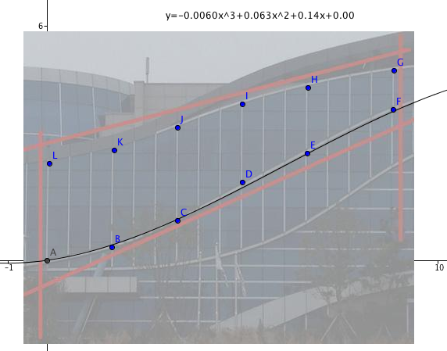
Figure 3. Lower Curve of Window and Corresponding Cubic Function

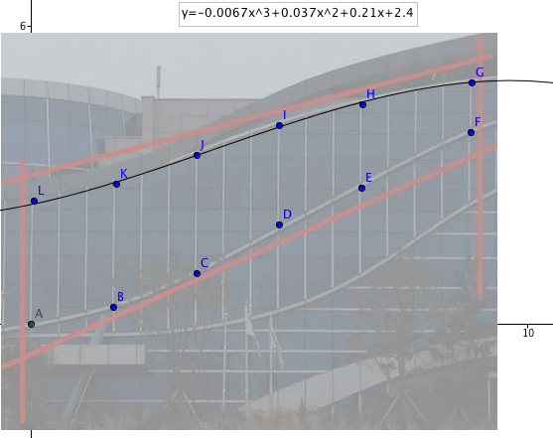
Figure 4. Upper Curve of Window and Corresponding Cubic Function

The following models were developed for the upper and lower windows.
(x represents the horizontal distance and y represents the vertical distance)
A scale will be developed later to convert final measurements attained.

Upper Window: $y=-0.0067x^{3}+0.037x^{2}+0.21x+2.4$

Lower Window: $y=-0.0060x^{3}+0.063x^{2}+0.14x-0.00$

In order to find the area between the upper window and lower window, I will integrate the polynomial functions.

Area = $\int_{0}^{8.88}{(\left(-0.0067x^{3}+0.037x^{2}+0.21x+2.4\right)-}\left(-0.0060x^{3}+0.063x^{2}+0.14x-0.00\right))dx$

=$\int_{0}^{8.88}{\left(-0.0007x^{3}-0.026x^{2}+0.07x+2.4\right)}dx$

=${\left[ \frac{-0.0007x^{4}}{4}-\frac{0.026x^{3}}{3}+\frac{0.07x^{2}}{2}+2.4x\right]}_{0}^{8.88}$

= 16.9 square units (3 significant figures)

The second method will use trapezoids. Using the same points, six trapezoids are found.

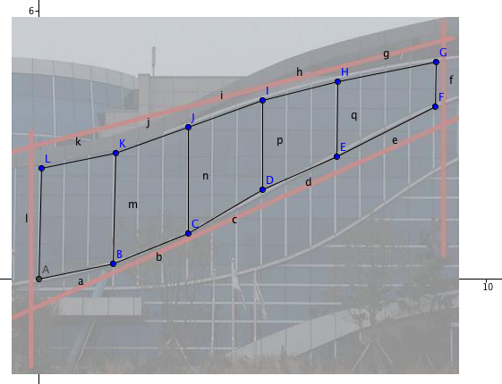
Figure 5. Trapezoid Method for Finding Window Areas

For each trapezoid, the left side vertical segment will serve as the base and the right side vertical segment will serve as the top. Height will be calculated by the change in x between points A and B, etc.

First Trapezoid Area = $\frac{1}{2}(2.48+2.48)×(1.66-0)$
=4.1168

Second Trapezoid Area = $\frac{1}{2}(2.48+2.38)×(3.34-1.66)$
=4.0824

Third Trapezoid Area = $\frac{1}{2}(2.38+2.00)×(5.00-3.34)$
=3.6354

Fourth Trapezoid Area = $\frac{1}{2}(2.00+1.68)×(6.66-5.00)$
=3.0544

Fifth Trapezoid Area = $\frac{1}{2}(1.68+1.00)×(8.86-6.66)$
=2.948

Total Area = Sum of all five trapezoid areas

= 17.837

= 17.8 square units (3 significant figures)

C) Conversion to metric measures

On the photograph within Geogebra, each linear unit measure is approximately equal to 2.4m. Therefore, each square unit is approximately equal to 2.4 times 2.4, or 5.8 m²

Definite Integration produced an area of 16.9 X 5.8 = 98 m²

Trapezoid method produced an area of 17.8 X 5.8 = 103 m²

D) Conclusion

Both the trapezoid method and the definite integration method produced reasonable and similar results. For both methods, some precision was lost due as the points were added on Geogebra. Unfortunately, the application does not allow fine tuning of the placement of each point so a ‘best fit’ approach was used, with some success, but it was not perfect.

For the cubic functions, an analytic approach to fit using sliders also had limitations. Inherently, Geogebra struggles to capture the precision requested and some estimation is required to identify the final position of some slider values.

It is worth looking more closely at the cubic functions and the points used. An upper curve which was concave down would be overestimating the transition segments between window joints. Conversely, an upper curve which was concave up would be underestimating the transition segments between window joints. The opposite would be true for the lower curves. However, as there were sections of both concavities throughout the domain, there should be some canceling of these effects.

The upper and lower limits of integration used were for extreme left and right endpoint. However, as I have pointed out, placement of points was not extremely precise so some judgment was used to find these limits.

For the trapezoid method, it was clear that some of the drawn segments did not follow the window segments very accurately. Perhaps using more segments, the errors would have been reduced.

Larger initial photographs would also have improved accuracy for both methods. I chose to round to 3 significant figures as it was apparent that and more precision would not be justified given the nature of each measurement taken, both from the original photo as well as from values obtained from Geogebra.

Further investigation would be valuable perhaps by breaking the domain into smaller pieces. Then, a variety of functions could be employed, using polynomials, exponentials, power functions, etc.

