**Exam Review Statistics**

**1.** In a school with 125 girls, each student is tested to see how many sit-up exercises (sit-ups) she can do in one minute. The results are given in the table below.

|  |  |  |
| --- | --- | --- |
| **Number of sit-ups** | **Number of students** | **Cumulative** **number of students** |
| 15 | 11 | 11 |
| 16 | 21 | 32 |
| 17 | 33 | *p* |
| 18 | *q* | 99 |
| 19 | 18 | 117 |
| 20 | 8 | 125 |

(a) (i) Write down the value of *p*.

(ii) Find the value of *q*.

(3)

(b) Find the median number of sit-ups.

(2)

(c) Find the mean number of sit-ups.

(2)

(Total 7 marks)

**2.** The histogram below represents the ages of 270 people in a village.

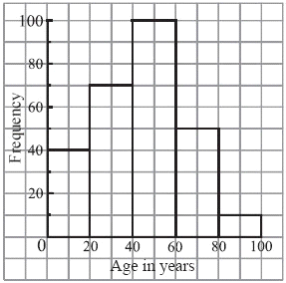

(a) Use the histogram to complete the table below.

|  |  |  |
| --- | --- | --- |
| Age range | Frequency | Mid-interval value |
| 0  age  20 | 40 | 10 |
| 20 ≤ age  40 |  |  |
| 40 ≤ age  60 |  |  |
| 60 ≤ age  80 |  |  |
| 80 ≤ age ≤100 |  |  |

(2)

(b) Hence, calculate an estimate of the mean age.

(4)

(Total 6 marks)

**3.** A set of data is

18, 18, 19, 19, 20, 22, 22, 23, 27, 28, 28, 31, 34, 34, 36.

The box and whisker plot for this data is shown below.

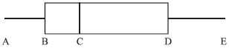

(a) Write down the values of A, B, C, D and E.

A = ...... B = ...... C= ...... D = ...... E = ......

(b) Find the interquartile range.

(Total 6 marks)

**4.** The cumulative frequency graph below shows the heights of 120 girls in a school.



(a) Using the graph

(i) write down the median;

(ii) find the interquartile range.

(b) Given that 60 of the girls are taller than *a* cm, find the value of *a*.

(Total 6 marks)

**5.** The population below is listed in ascending order.

5, 6, 7, 7, 9, 9, *r*, 10, s, 13, 13, *t*

The median of the population is 9.5. The upper quartile *Q*3 is 13.

(a) Write down the value of

(i) *r*;

(ii) *s*.

(b) The mean of the population is 10. Find the value of *t*.

(Total 6 marks)

**6.** The 45 students in a class each recorded the number of whole minutes, *x*, spent doing experiments on Monday. The results are *****x* = 2230.

(a) Find the mean number of minutes the students spent doing experiments on Monday.

Two new students joined the class and reported that they spent 37 minutes and 30 minutes respectively.

(b) Calculate the new mean including these two students.

(Total 6 marks)

**7.** Let *a*, *b*, *c* and *d* be integers such that *a* < *b*, *b* < *c* and *c* = *d*.

The mode of these four numbers is 11.  
The range of these four numbers is 8.  
The mean of these four numbers is 8.

Calculate the value of each of the integers *a*, *b*, *c*, *d*.

(Total 6 marks)

**8.** Given the following frequency distribution, ﬁnd

(a) the median;

(b) the mean.

|  |  |  |  |  |  |  |
| --- | --- | --- | --- | --- | --- | --- |
| Number (*x*) | 1 | 2 | 3 | 4 | 5 | 6 |
| Frequency (*f* ) | 5 | 9 | 16 | 18 | 20 | 7 |

(Total 4 marks)