**Exam Review Probability**

**1.** A **four-sided** die has three blue faces and one red face. The die is rolled.

Let *B* be the event a blue face lands down, and *R* be the event a red face lands down.

(a) Write down

(i) P (*B*);

(ii) P (*R*).

(2)

(b) If the blue face lands down, the die is not rolled again. If the red face lands down, the die is rolled once again. This is represented by the following tree diagram, where *p*, *s*, *t* are probabilities.

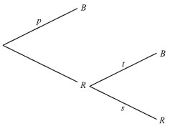

Find the value of *p*, of *s* and of *t*.

(2)

Guiseppi plays a game where he rolls the die. If a blue face lands down, he scores 2 and is finished. If the red face lands down, he scores 1 and rolls one more time. Let *X* be the total score obtained.

(c) (i) Show that P (*X* = 3) = 

(ii) Find P (*X* = 2).

(3)

(d) (i) Construct a probability distribution table for *X*.

(ii) Calculate the expected value of *X*.

(5)

(e) If the total score is 3, Guiseppi wins $10. If the total score is 2, Guiseppi gets nothing.

Guiseppi plays the game twice. Find the probability that he wins exactly $10.

(4)

(Total 16 marks)

**2.** The weights of chickens for sale in a shop are normally distributed with mean 2.5 kg and standard deviation 0.3 kg.

(a) A chicken is chosen at random.

(i) Find the probability that it weighs less than 2 kg.

(ii) Find the probability that it weighs more than 2.8 kg.

(iii) Copy the diagram below. Shade the areas that represent the probabilities from parts (i) and (ii).

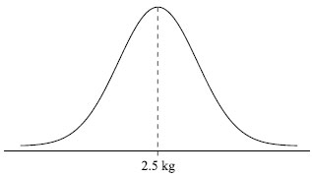

(iv) **Hence** show that the probability that it weighs between 2 kg and 2.8 kg is 0.7936 (to four significant figures).

(7)

(b) A customer buys 10 chickens.

(i) Find the probability that all 10 chickens weigh between 2 kg and 2.8 kg.

(ii) Find the probability that at least 7 of the chickens weigh between 2 kg and 2.8 kg.

(6)

(Total 13 marks)

**3.** A discrete random variable X has a probability distribution as shown in the table below.

|  |  |  |  |  |
| --- | --- | --- | --- | --- |
| *x* | 0 | 1 | 2 | 3 |
| P(*X* = *x*) | 0.1 | *a* | 0.3 | *b* |

(a) Find the value of *a* + *b*.

(2)

(b) Given that E(*X*) =1.5, find the value of *a* and of *b*.

(4)

(Total 6 marks)

**4.** A bag contains four apples (*A*) and six bananas (*B*). A fruit is taken from the bag and eaten. Then a second fruit is taken and eaten.

(a) Complete the tree diagram below by writing probabilities in the spaces provided.

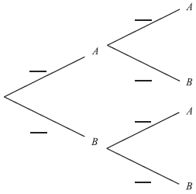

(3)

(b) Find the probability that one of each type of fruit was eaten.

(3)

(Total 6 marks)

**5.** The Venn diagram below shows information about 120 students in a school. Of these, 40 study Chinese (*C*), 35 study Japanese (*J*), and 30 study Spanish (*S*).

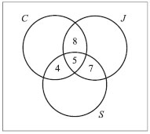

A student is chosen at random from the group. Find the probability that the student

(a) studies exactly two of these languages;

(1)

(b) studies only Japanese;

(2)

(c) does not study any of these languages.

(3)

(Total 6 marks)

**6.** Two restaurants, *Center* and *New*, sell fish rolls and salads.

Let *F* be the event a customer chooses a fish roll.

Let *S* be the event a customer chooses a salad.

Let *N* be the event a customer chooses neither a fish roll nor a salad.

In the *Center* restaurant P(*F*) = 0.31, P(*S*) = 0.62, P(*N*) = 0.14.

(a) Show that P(*F*  *S*) = 0.07.

(3)

(b) Given that a customer chooses a salad, find the probability the customer also chooses a fish roll.

(3)

(c) Are *F* and *S* independent events? Justify your answer.

(3)

At *New* restaurant, P(*N*) = 0.14. Twice as many customers choose a salad as choose a fish roll. Choosing a fish roll is **independent** of choosing a salad.

(d) Find the probability that a fish roll is chosen.

(7)

(Total 16 marks)

**7.** The heights of certain flowers follow a normal distribution. It is known that 20 of these flowers have a height less than 3 cm and 10 have a height greater than 8 cm.

Find the value of the mean ** and the standard deviation .

(Total 6 marks)

**8.** Events *E* and *F* are independent, with P(*E*) =  and P(*E*  *F*) = . Calculate

(a) P(*F*);

(b) P(*E*  *F*).

(Total 6 marks)

**9.** A factory makes calculators. Over a long period, 2% of them are found to be faulty. A random sample of 100 calculators is tested.

(a) Write down the expected number of faulty calculators in the sample.

(b) Find the probability that three calculators are faulty.

(c) Find the probability that more than one calculator is faulty.

(Total 6 marks)

**10.** Consider events *A*, *B* such that P (*A*)  0, P (*A*)  1, P (B)  0, and P (B)  1.

In each of the situations (a), (b), (c) below state whether *A* and *B* are

mutually exclusive (M);  
independent (I);  
neither (N).

(a) P(A|B) = P(A)

(b) P(A  B) = 0

(c) P(A  B) = P(A)

(Total 6 marks)